CSA1715-ARTIFICIAL INTELLIGENCE
LAB PROGRAM- 11
06-08-2026
11. Write the python program for Map Coloring to implement CSP.

Aim
To implement the Map Coloring Problem using the Constraint Satisfaction Problem (CSP) approach in Python.

Algorithm
- Read the regions and their adjacent regions.
- Assign one of three colors.
- Check whether adjacent regions have different colors.
- If valid, continue.
- Otherwise, backtrack.
- Display the final color assignment.
Program
graph={}
n=int(input("Enter number of regions: "))

for i in range(n):
r=input("Region: ")
graph[r]=input("Adjacent regions: ").split()

colors=["Red","Green","Blue"]
result={}

def solve(r):
if r==len(graph):
return True
region=list(graph.keys())[r]
for c in colors:
ok=True
for adj in graph[region]:
if result.get(adj)==c:
ok=False
if ok:
result[region]=c
if solve(r+1):
return True
del result[region]
return False

solve(0)

print("\nColor Assignment")
for i in result:
print(i,"=",result[i])

Input
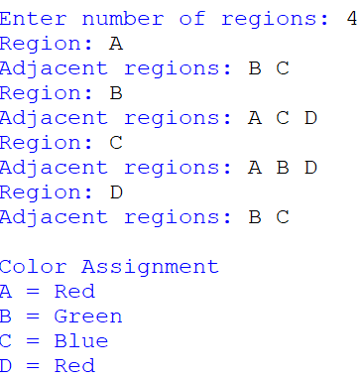
Output

Result:
The Map Coloring Problem was successfully solved using the Constraint Satisfaction Problem (CSP) approach.

